Dr.ZAKIR HUSAIN COLLEGE, ILAYANGUDI
PG DEPARTMENT OF MATHEMATICS

PROJECT TITLE:
MEASURING SUCCESS IN TALENT MANAGEMENT

SUBMITTED BY:
TEAM MEMBERS NAME | UNIVERSITY REGISTRATION NUMBER | NAAN MUDHALVAN ID | SMARTINTERNZ ID
RENGANATHAN. G.R | 0621121056 | asalu6621121056 | NM2023TMID13076
PAVIRAJ. P | 0621121051 | asalu6621121051 | NM2023TMID13076
JEYAPRAKASH.S | 0621121044 | asalu6621121044 | NM2023TMID13076
MURALIDHARAN.B | 0621121049 | asalu6621121049 | NM2023TMID13076
SATHEESH KUMAR.N | 0621121057 | asalu6621121057 | NM2023TMID13076

FACULITY INCHARGE:
Dr. B. FATHIMA KANI
ASSISTANT PROFESSOR
DEPARTMENT OF MATHEMATICS
Dr. ZAKIR HUSAIN COLLEGE, ILAYANGUDI
1.INTRODUCTION:
1.1 OVERVIEW:
Talent management is an integral part of human resource management. Talent management can be defined as a a deliberate approach implemented to recruit or hire, develop and retain people with required aptitude or skills to meet the present and future goals or needs of the organization. It is the creation and maintenance of a supportive and pro-people organizational culture.

1.2 PURPOSE:
1. The purpose of talent management to identify, recruit and hold on to people who drive the success of your organisation
2. It’s top priority, strategic process for forward looking People Companies who understand that their company performance depends on their workforce.
3. Performance and talent management is a key function of the modern HR development.
4. These People Companies go out of their way to nurture and develop the talent that powers their growth and Effectiveness.
5. Collaboration and social skills can be as important as intellectual calibre or productivity.

2. PROBLEM DEFINITION & DESIGN THINKING:
2.1 EMPATHY MAP:
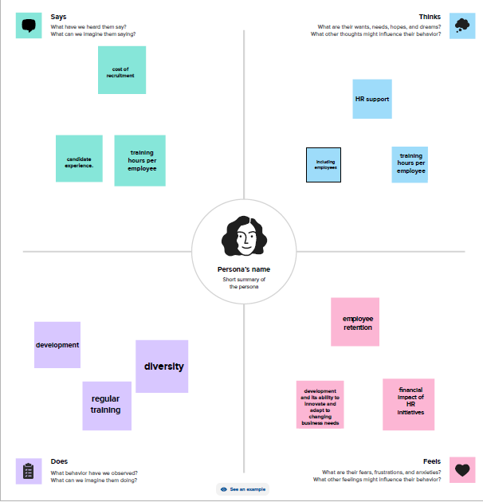

2.2 IDEATION & BRAINSTORMING MAP:
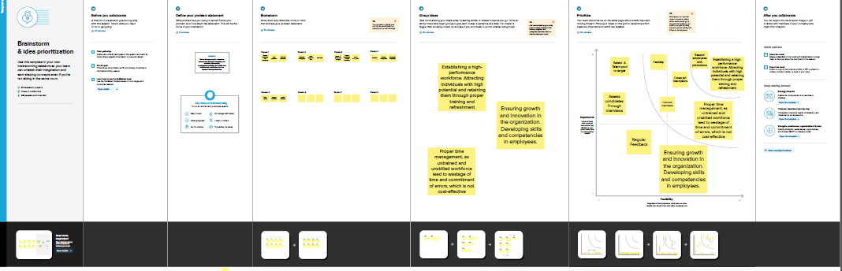

3. RESULT:

DASHBOARDS AND STORIES:
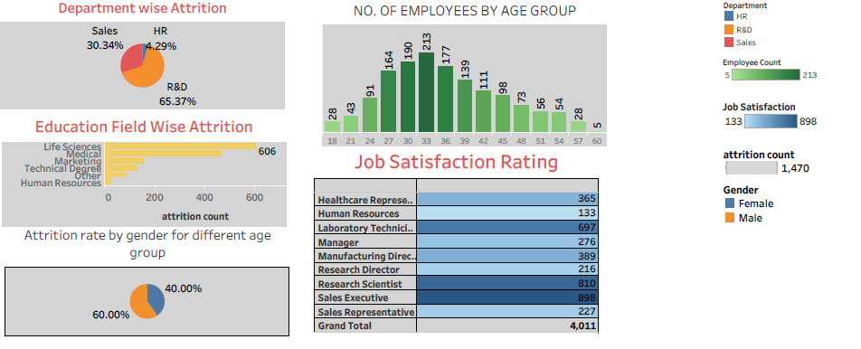
STORY 1:
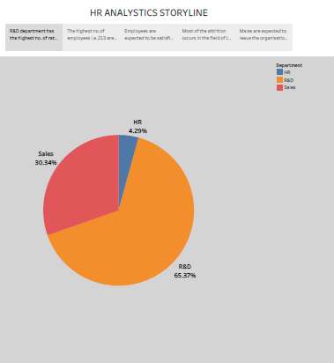

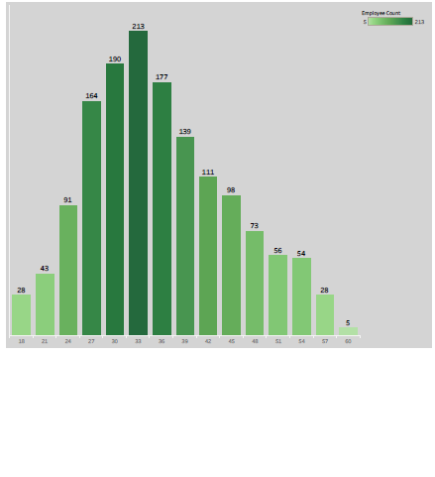
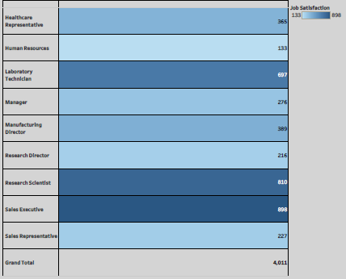

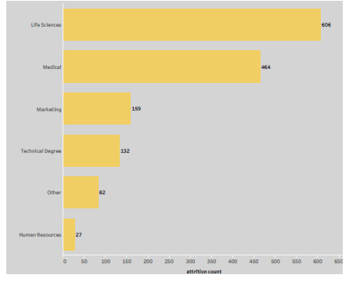

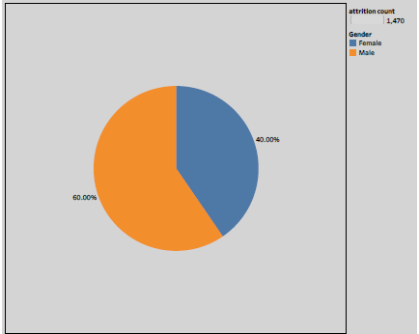

4. ADVANTAGE & DISADVANTAGE:

ADVANTAGE OF TALENT MANAGEMENT:
- Help in ascertaining the right person is deployed in the right position.
- Contributes in retaining their top talent.
- Better hiring by hiring assessments.
- Help in understanding employees better and shaping their future.
- Promotes effective communication across different disciplines.

DISADVANTAGE OF TALENT MANAGEMENT:
- The implementation of talent management program could be expensive in terms of time, resources and financial costs.
- Lack of support from line managers can impede the level of commitment from employees.
- A core drawback of talent management is, it can contribute in raising the conflicts between HR and management by not reaching to proper agreement or consensus.

5. APPLICATIONS:
A talent management system, or TMS, is an integrated software platform that supports core talent management processes, including recruitment, employee on boarding, performance management, learning and professional development, compensation management and succession planning.

6.CONCLUSION:
Carefully planned approach in building talent management started with luxing PMS. Talent management is about the systematic attraction, identification, development, engagement, retention and deployment of talented individuals who are of particular value to an organisation and professional practice.
It takes place at a strategic and individual level
To be successful, planning is essential
Talent management provides individuals with access to the right opportunities, exposure, stretch and development to reach their potential, whether this be in their current role or for a future role.

7. FUTURE SCOPE:
Talent management refers to the entire scope of the human resources (HR) process. This includes attracting, developing, motivating, the retention of high-performing employees. Simply put, talent management is a process with the set goal of maintaining a high-performing workforce through the management of employees.

